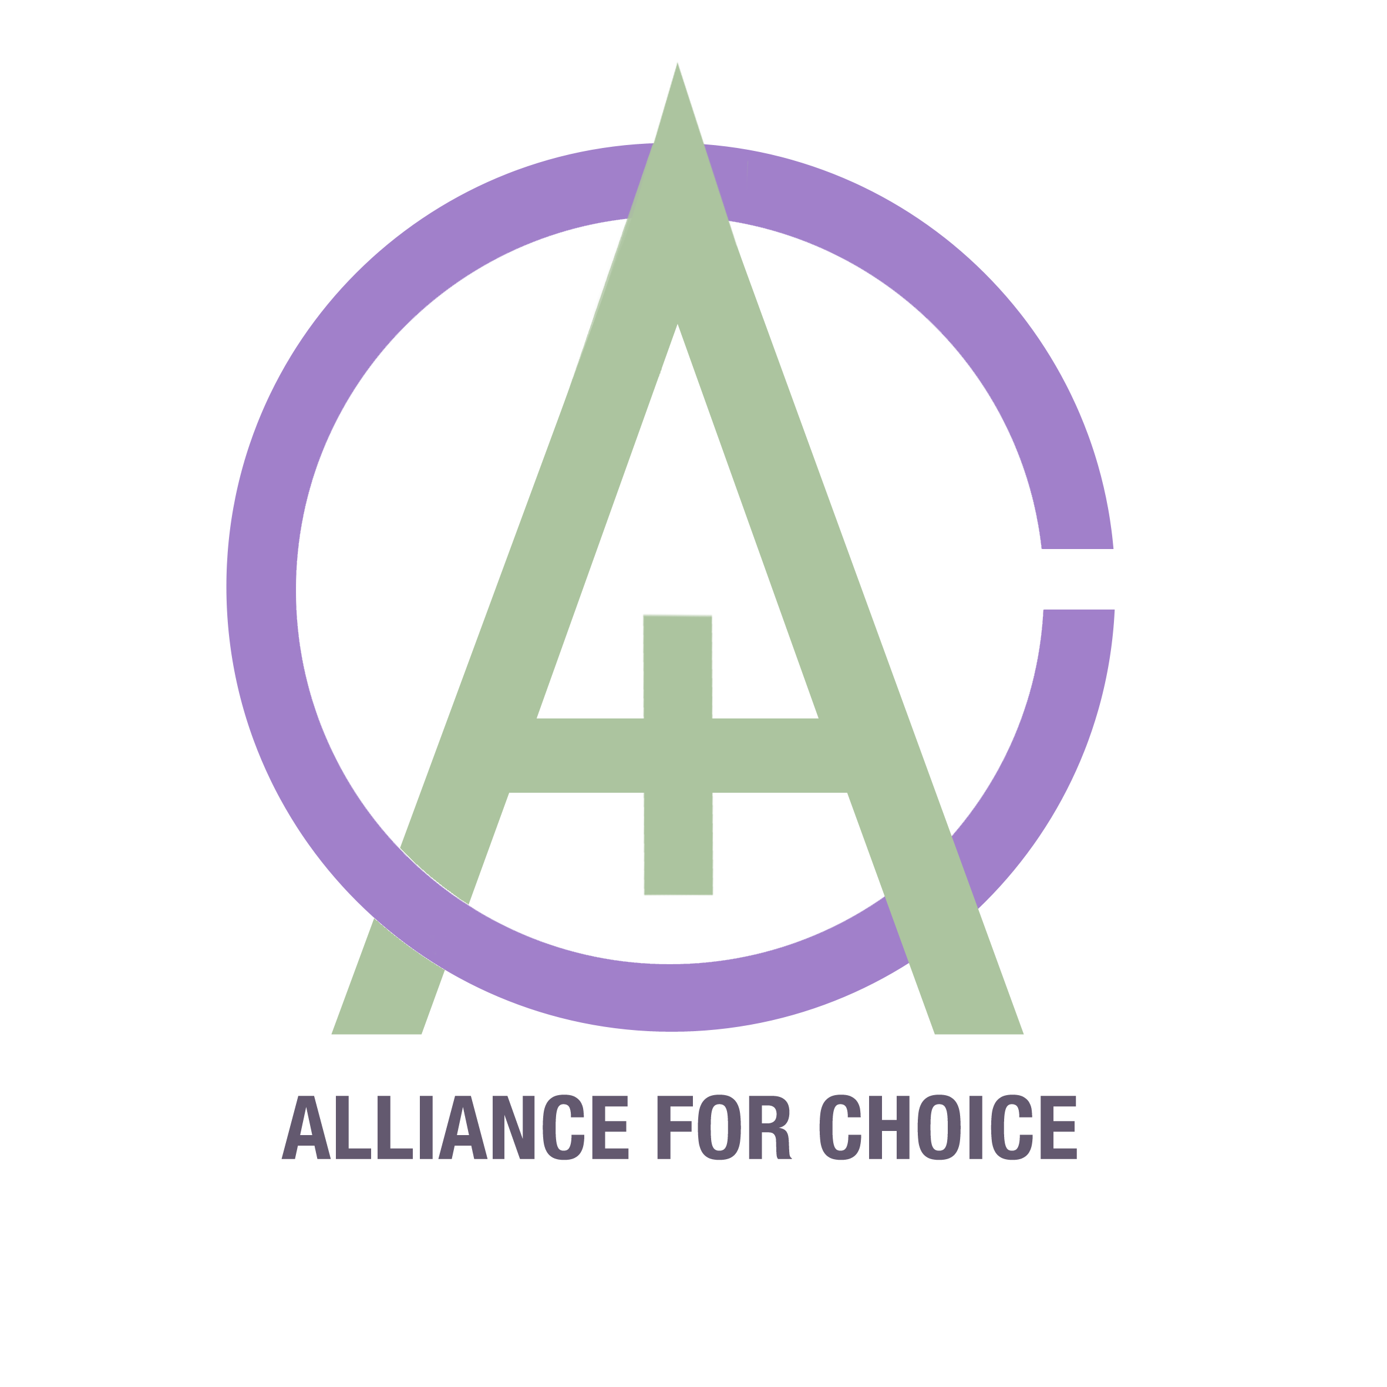

ALLIANCE FOR CHOICE;

written submission to the Joint Committee on Human Rights on Draft Domestic Violence and Abuse Bill.

About Alliance for Choice:
Alliance for Choice was set up in 1996, we campaign for free, safe and legal abortion access in Northern Ireland, an end to the criminalisation of women and pregnant people and an end to the harassment of people using reproductive health services. Much of our work has been about giving voice to the tens of thousands of abortion seekers from Northern Ireland who had abortions in England and elsewhere, or at home & alone with the threat of prosecution and without medical support. Alliance for Choice are currently supported by the Joseph Rowntree Reform Trust as well as donations from Trade Unions and individual donors via our Local Giving page.
Alliance for Choice is made up of people who have dealt with untenable pregnancies, we are people who have had abortions and are survivors of sexual abuse Intimate Partner Violence and sexual harassment. In the absence of any statutory bodies willing to, we provide abortion seekers with advice, signposting, provision and legal help. We are also often the first point of contact or the only one that people feel safe to talk to about abortion pills, the chances of prosecutions or serious side effects.
AFC have been the recipients of both the “Liberty Long Walk to Freedom” Award 2017, the Political Studies Association “Campaign of the Year” Award in 2018.
Contact:
Emma Campbell ,
Co-Chair - 07894063975
campbell.emma@gmail.com

The draft Domestic Violence and Abuse Bill remains non-compliant with the Convention by omitting a significant portion of the UK population without recourse to the Bill’s provisions on the basis of grounds which are proscribed by the Convention. Article 4(3) of the Istanbul Convention states that ‘provisions of this Convention by the Parties, in particular measures to protect the rights of victims, shall be secured without discrimination on any ground such as [...] national or social origin [...or...] migrant or refugee status’.
Below you will find evidence as to why restricting the extent of the Bill is a barrier to ratifying the Convention.

Migrant Status
Article 4(3) specifies that discrimination based on migrant or refugee status is not permitted under the Istanbul Convention; equal protection for all survivors of domestic abuse must be provided for. The Government's consultation paper on the Domestic Abuse Bill recognised that insecure immigration status may also impact on a victim’s decision to seek help. The continued prioritisation of immigration enforcement over the need to protect survivors of domestic abuse means that migrant women are not afforded equal protection by this bill and will continue to feel that they are categorised as ‘illegal immigrants’ rather than ‘victims’ by our justice system.
Accessing abortion in Northern Ireland requires complicated navigation of the health system. Most GPs and hospital staff are too afraid to recommend travel to England and the Dept. of Health in NI have refused to release guidelines since October 2017. These complications compound difficulties for women who are new to the country, often afraid and do not have the same access to this information, face language barriers or lack knowledge of where to access assistance.
On top of which, the tools of Immigration Enforcement prevent survivors with insecure immigration status from accessing the vital services they need, as they fear reporting crimes due to the real risk of detention or deportation. Perpetrators of abuse are known to use these mechanisms of coercive control, by threatening to report victims to the Home Office if they go to complain to the Police. By rendering victims and their children dependent on their perpetrators for residency in the UK, these women subsequently face a harrowing choice between staying with their abuser and destitution.
This bill also fails to address the fact that without access to benefits, migrant survivors with no access to public funds are often more likely to be turned away from refuges unable to provide them with safe accommodation unless they can claim housing support. This bill should have made provision for migrant survivors of abuse in this predicament. If it fails to, migrant women will be denied safety by a discriminatory, two-tier system, in direct contravention of the non-discrimination requirement set out under Article 4(3) of the Istanbul Convention which requires equal treatment of survivors.

Victims and Survivors of Domestic Abuse and Sexual Violence
In Northern Ireland, a lack of access to legal abortion beyond saving grave or fatal health outcomes means that every person who attempts to access it outside of the strict parameters of the law is at risk of prosecution, but equally it has the effect of turning the victims of incest, rape and domestic violence into criminals. As stated by the recent CEDAW inquiry;
“the criminalisation of abortion places female victims of rape or incest at risk of being treated as criminals themselves and has contributed to the underreporting of rape, fearing prosecution and conviction”.
For this to continue only in Northern Ireland is a form of State violence against women and girls and has no perceivable benefits to women or to the wider community.”
Alliance for Choice maintains this is clear evidence of State violence and abuse of women in the denial of abortion services in NI for those who need them. This does not only apply to those for whom the crisis pregnancy is a result of abuse or of a sexual crime, but to every person who risks their life and health by self-administering abortion pills without access to emergency medical care for fear of prosecution, or those who are forced to travel for abortion healthcare, or those who have been forced to endure a pregnancy they know will not survive against their wishes. CEDAW has been unequivocal in its summary

Trans People:
It’s vital we include Trans* experiences of pregnancy which can range from mental health triggering dysphoria right up to wanting pregnancy despite causing conflict for transition treatment. We also know that there are disproportionately high levels of coercive control meted out to trans people in intimate relationships, which can often take the form of the removal or enforcement of contraception, the forced termination or coercion of pregnancy as well as the threat of outing to one’s family. These are sensitive issues that are further compounded by a lack of accessible and safe abortion care in a local setting.
Devolution
The exclusion of Northern Ireland is not consistent with (a) the Preventing and Combating Violence Against Women and Domestic Violence (Ratification of Convention) Act 2017’, which extends to Northern Ireland; or with (b) the ‘Ratification of the Council of Europe Convention on Combating Violence Against Women and Domestic Violence (Istanbul Convention) – Report on Progress’ which states that ‘The Convention covers both reserved and devolved areas, and this report therefore covers the whole of the UK.’, and that ‘the Devolved Administrations are also considering what legislative or other changes are necessary for compliance with the Convention in their territories’.
The Northern Ireland Department of Justice is currently consulting on the need for stalking legislation. This consultation closes on 21st February but without a functional Assembly, no change to the law will be possible from within Northern Ireland.
The scope of the measures the Government is proposing to comply with the Convention are restricted to certain territories within the UK. The explanatory notes to the Convention are clear that it is
“…incompatible with the object and purpose of the Convention for states Parties to exclude parts of their territory from application of the Convention without valid reason”
The ‘Explanatory Report to the Council of Europe Convention on preventing and combating violence against women and domestic violence notes’, is clear that exclusion of territories is not compatible with Istanbul Convention.:
‘377. Paragraph 1 specifies the territories to which the Convention applies. Here it should be pointed out that it would be incompatible with the object and purpose of the Convention for states Parties to exclude parts of their territory from application of the Convention without valid reason (such as the existence of different legal systems applying in matters dealt with in the Convention).
378. Paragraph 2 is concerned with extension of application of the Convention to territories for whose international relations the Parties are responsible or on whose behalf they are authorised to give undertakings.’
The UK has signed the Istanbul Convention: in doing so, it is legally obliged under Article 18 of the Vienna Convention on the Law of Treaties 1980 to ‘refrain from any acts which would defeat the object and purpose of a treaty’ once a treaty has been signed, even before ratification. The exclusion of protections for migrant women, and omission of Northern Ireland is absolutely contrary to the Government’s own stated commitment to ensuring that the UK is compliant with the terms of the Convention prior to ratification.
With regard to cross-cutting obligations to Committee on the Convention to Eliminate Discrimination against Women (CEDAW); Westminster has consistently used devolution to justify the uneven application of the CEDAW obligations across the UK.
There is no visible commitment to gender equality in public policy. The NI Government’s Review of the Gender Equality Strategy 2006-2016, conducted in 2013 determined that the Strategy ‘was a positive step but that progress against it had been limited and implementation and monitoring could be improved’. Recommendations in the review were not acted on and the Government’s Gender Advisory Panel has not met since February 2016.
Northern Ireland is a devolved nation within the UK, but the devolved Assembly collapsed in January 2017. As outlined above, the lack of a devolved Government cannot be used to explain or justify the lack of progress on substantive issues. Moreover, there was little progress on the implementation of the Convention in the first three years since the last examination and before the collapse of the NI institutions.

Conclusion
The scope of this Bill must be amended with haste. The unprecedented political circumstances with regard to the devolved Assembly, reinforce rather than mitigate the responsibilities of Westminster. There are clear overlaps between protecting women from violence and providing access to safe, legal and local abortion healthcare and there are strong links between a person’s migrant status and her ability to seek recourse to safety and services in light of Domestic Abuse or sexual violence. Omitting the extent of the Bill which would allow for the provisions needed in these circumstances, omits many of the most vulnerable victims from the intent of the ratification of such a treaty.

Joseph Rowntree Reform Trust http://www.jrrt.org.uk/
Liberty Award https://www.libertyhumanrights.org.uk/news/press-releases-and-statements/liberty-honour-northern-ireland-abortion-rights-movement-human
PSA Award https://www.psa.ac.uk/psa/news/psa-awards-2018-award-winners-announced
The Committee assesses the gravity of the violations in NI in light of the suffering experienced by women and girls who carry pregnancies to full term against their will due to the current restrictive legal regime on abortion. It notes the great harm and suffering resulting from the physical and mental anguish of carrying an unwanted pregnancy to full term, especially in cases of rape, incest and severe foetal impairment, particularly FFA.83 The situation gives NI women three deplorable options: (a) undergo a torturous experience of being compelled to carry a pregnancy to full term; (b) engage in illegal abortion and risk imprisonment and stigmatisation; or, (c) undertake a highly stressful journey outside NI to access a legal abortion. Women are thus torn between complying with discriminatory laws that unduly restrict abortion or risk prosecution and imprisonment. The systematic nature of the violations stems from the deliberate retention of criminal laws and State policy disproportionately restricting access to sexual and reproductive rights, in general, and highly restrictive abortion provision, in particular. Westminster and NI authorities acknowledge the magnitude of the phenomenon and choose to export it to England where NI women travel to access abortions. The UK’s observations and interviews with NI authorities clarify the deliberate intention neither to decriminalise abortion nor to expand the grounds for legal abortion. Availability of abortion in other parts of the State party does not absolve it of its responsibility under the Convention to ensure accessibility in NI. (our highlights)
The most recent published review dates from 2013.
Department for Communities Gender Equality Strategy 2006-2016
The most recent published review 2013, p5..
The UK Common Core Document does not reflect recent changes (para 15). The Northern Ireland Assembly now has 90 members and an Executive would be made up of a First Minister, Deputy First Minister, two Junior Ministers and eight departmental ministers. In the restructuring that reduced the number of departments for equality, including gender equality moved from the responsibility of the First Minister and deputy First Minister to the Department for Communities, a move considered negative by many.
July 2013 – January 2017

